Hrithik Shivnauth

DS210

HW7

Question 1:

For the first question, we design a data type shape where we store three different shapes. We use an Enum to store these shapes because they are all of data type f64.

Next, we create an auxiliary function that is used to make the four shapes. Then we implement the original shape Enum using 4 different methods which compute the area, perimeter, and double perimeter, and verify the parameters for each shape. The results are shown below:

As we can see, the parameters are verified, and for the values of:

[3,4,5] – triangle the area and double perimeter are correct.

[2,3] – rectangle the area and double perimeter are correct.

[1.0] – circle the area and double perimeter are correct.

Question 2:

For the second question, we create a struct and a trait with the number and length of the sides being parameters.

The four methods produce the perimeter area radius and apothem for each different number and length of sides.

If we are showing the area of a circle that is circumscribed, the area of the circle is greater than the area of the polygon. In this case, the circle has the same radius as the length of the apothems. Hence, we can use the area of a circle with one radius length.

For different side numbers of [ 6,12,24,128,256,512,1024,2048,65536]

For side length with a radius of 5.0

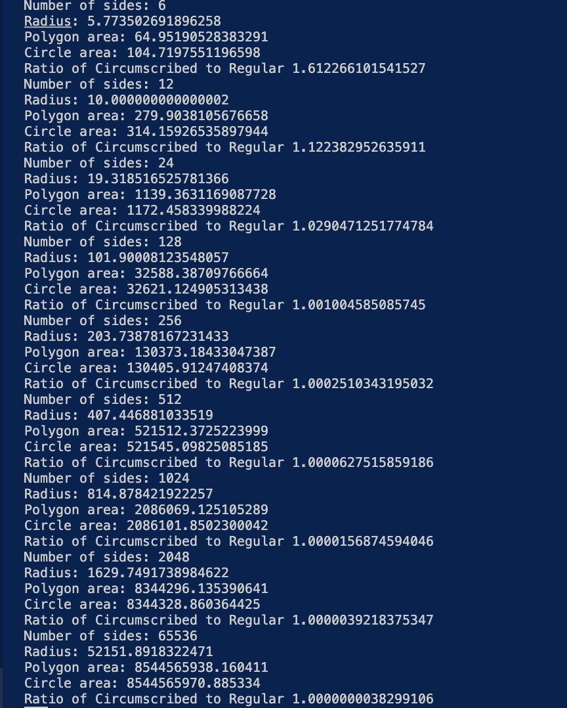

One can observe that as the side lengths increase the difference between the polygon area and circle area decreases. For example, the area of a polygon and circle with side length 6 is 64 and 104 approximately and the area for a side length of 65536 is 8544565838 and 8544565970 approximately. We can also see the ratios of these areas become closer to 1 as the side length increases. The ratio of difference is becoming more equal because a polygon with more side lengths begins to appear like a circle.